|  |  |  |
| --- | --- | --- |
| Computer Networks (BSE-7A)  Quiz 02 (Fall 2023). Instructor: Dr. Syed M. Irteza | | Name: ***SOLUTION*** |
| Date: 2023-10-10 | | Roll Number: |
| Total Marks: 10 | Time Allowed: 10 mins |

1. Which form of RDT handles garbled ACKs/NAKs? (1m)
   1. 1.0
   2. 2.0
   3. ***2.1 \*\*\****
   4. All forms of RDT
2. Congestion control is something you would associate with? (1m)
   1. SNMP
   2. UDP
   3. DNS
   4. ***TCP \*\*\****
3. Describe the difference in demultiplexing at the server if we use TCP instead of UDP (3m)

***With UDP, the receiving host (i.e., server) receives a UDP segment, it just checks the destination port, and directs the UDP segment to the socket with that port number.***

***With TCP, the receiving host uses all four values (4-tuple) to direct the TCP segment to the appropriate socket (source IP address, source port number, destination IP address, destination port number). Each socket is associated with a different connecting client.***

1. Draw the finite state machine for the receiver if we assume RDT 2.0 (3m)

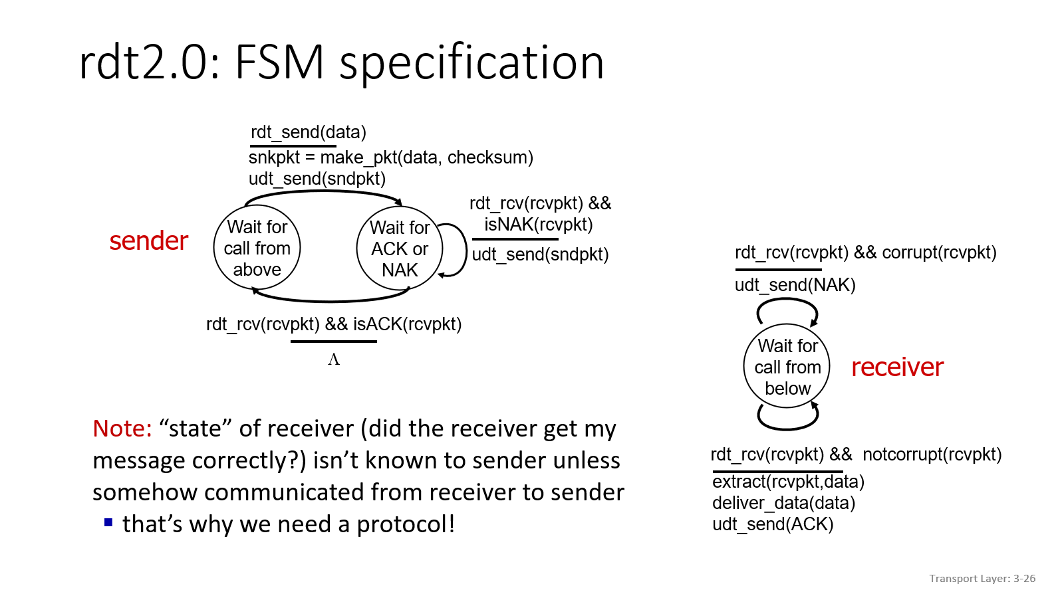

1. What is checksum? Please illustrate with a very simple example (2m)

***Checksum is a method that enables the detection of errors (i.e., flipped bits) in a transmitted segment. It is calculated and stored as a header field at the sender side, and then computed and then compared at the receiver side.***

***EX: Calculate UDP checksum of the following sequence: 11100110011001101101010101010101***

***First of all, divide the bit stream on to two parts of 16-bit each.***

***The two bit-streams will be: 1110011001100110 and 1101010101010101.***

***Add these two bit-streams, so the addition will be:***

***1 1 1 0 0 1 1 0 0 1 1 0 0 1 1 0***

***1 1 0 1 0 1 0 1 0 1 0 1 0 1 0 1***

***---------------------------------------***

***1 1 0 1 1 1 0 1 1 1 0 1 1 1 0 1 1***

***1 0 1 1 1 0 1 1 1 0 1 1 1 1 0 0 (after wraparound)***

***Now apply one's complement to this bit stream. So, the checksum will be: 0100010001000011.***